PRESS RELEASE
Prague, 21 August 2020

KRIŠTOF KINTERA: NEUROPOLIS

25 August – 7 November 2020
Galerie Zdeněk Sklenář
Schönkirch Palace
Mikulandská 7, Prague 1 – New Town, CZ|
Tuesday to Saturday from 1 pm to 6 pm
www.zdeneksklenar.com

Galerie Zdeněk Sklenář is pleased to present Krištof Kintera’s exhibition Neuropolis. This is the artist’s first solo show since 2017, when Nervous Trees was held at the Rudolfinum Gallery in Prague. For more than two months, the gallery’s exhibition spaces will become the setting for a living art installation – a studio, or an imaginary laboratory, offering the spectator a close-up look at the process of artistic creation. The installation, which has been designed as an invasion of the physical exhibition space, is the ideological continuation of Kintera’s earlier project at the Rudolfinum – mainly of the large installation Postnaturalia made from electronic waste. In his show at Galerie Zdeněk Sklenář Kintera takes a new look at architecture and its relation to the urban landscape – he explores the phenomenon of the Urbanocene and shows his interest in the parallels between how neural networks function in the human brain and the functioning of transport, energy, socio-cultural and digital networks and hubs and the way in which they are intertwined in metropolises. Kintera’s urban landscapes are created from banal, often useless and discarded items from daily life – an electric coil looks like a granary, a capacitor resembles a gas holder, a fluorescent tube an elegant skyscraper and a ski pole is a television tower, while memory slots represent suburban housing. An important aspect of his new work is the change in scale, when miniature objects placed together create a large-scale installation. As in the case of Kintera’s exhibition at the Rudolfinum Gallery, here we are also witness to a living process of proliferation, the power of growth, the apocalypse of extinction – which, according to the artist, has a special hint of sex appeal – and the banality of emptied content.

Objects reminiscent of skyscrapers or stelae created from obsolete fluorescent tubes and a conglomeration of electrical waste, used ski poles looming up towards the ceiling like TV towers, impressive urban landscapes constructed from worthless light bulbs, discarded parts and banal objects from everyday life: blenders, telephones, toasters or computer parts – these all contribute to the landscape motifs of the Neuropolis exhibition. For this show, Kintera was inspired by the book Scale by Geoffrey West, the American scientist and professor who popularised the concept of ​​the Urbanocene and Anthropocene, and also by the idea of ​​substituting scales of measure in architecture and the urban landscape. The way in which Kintera builds an urban landscape resembles how an architect or urban planner designs the concept for a new city.

The artist believes that the landscape in which we live is a gigantic elaborately structured network of feeder pipes, conduits, collectors, cables, gas pipelines, water mains, sewers, drainage, oil pipelines, industrial food growing facilities, roads, hubs, solar panels, data centres and call centres. According to Kintera, all of this appears not only in a clearly visible form, but also in a covert multi-layered way, underground and in the walls of buildings.

“I’ve turned my focus to the landscape, and am currently devoting myself to ‘landscape painting’ and ‘reliefs’. I’m fascinated by changes and substitutions of scale, when something very small, sophisticated and carefully contrived is reminiscent of something big, which is also highly developed, promoted by architects and developers, and constructed by builders. Micro is interwoven with macro; that which is above is also below, what is small is also big, and the small is in big and the big in small. And in the middle of it all there are myriads of ants rushing about, or we people, with an entire range of personal desires, opinions, feelings and problems,” says Krištof Kintera about his installation.

Kintera is presenting brand new objects at Galerie Zdeněk Sklenář – sculptures he calls stelae or skyscrapers. This time, however, his sculptures perform no function; they do not move or speak; they are purposeless and banal. “I think about sculptures as batteries in which the artist’s time, thoughts, and energy are stored,” concludes Kintera.

In addition to objects, the exhibition includes drawings that quite often convey a humorous message.

Two guided tours with the artist have been planned to accompany the exhibition, the first on 23 September 2020 and the second on 21 October 2020, both starting at 6 pm.

In conjunction with the exhibition, Galerie Zdeněk Sklenář is also publishing a book from the Czech Laozi Edition – Laozi’s Dao De Jing: The Book of the Dao and Its Virtue, as translated by Rudolf Dvořák in 1920 and with illustrations by Krištof Kintera. The cover of all 1,000 copies has an original illustration by artist, and the first 100 copies are signed and numbered.

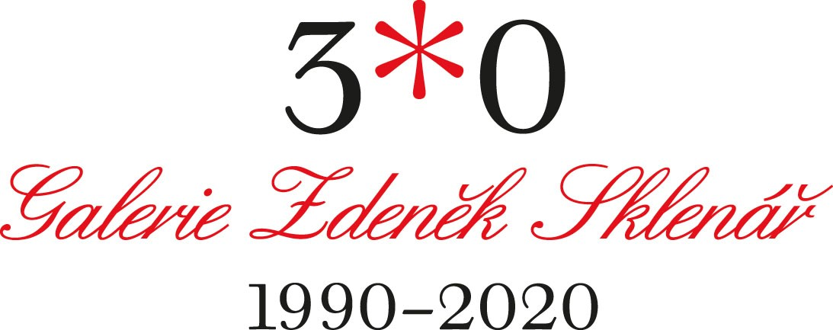

For more information, please contact Galerie Zdeněk Sklenář:
press@zdeneksklenar.cz
+420 720 435 754, +420 605 936 390
www.zdeneksklenar.com
www.instagram.com/galerie_zdenek_sklenar/
https://www.facebook.com/galerie.zdenek.sklenar.cz/

